Handwriting Policy

King George V
Rationale:

We believe that handwriting should enable children to master written communication. Handwriting is a movement skill that requires children to become familiar with the formation of each letter and the correct sequence of strokes. For most writers, writing fluency will be achieved by frequent practice throughout the week. We want to ensure that children learn to form the letters of the alphabet with the correct sequence of strokes.

Letter formation and Joins (kinetic letter)

The Six Letter Families:

- Jumper Family: h,b,r,n,m,p
- Abracadabra Family: c,o,a,d,g,q,s
- Window Cleaner Family: l,t,i,u
- Special Squirter: e
- Fisher Family: y,j,f
- Slider Family: k,v,w,x,z
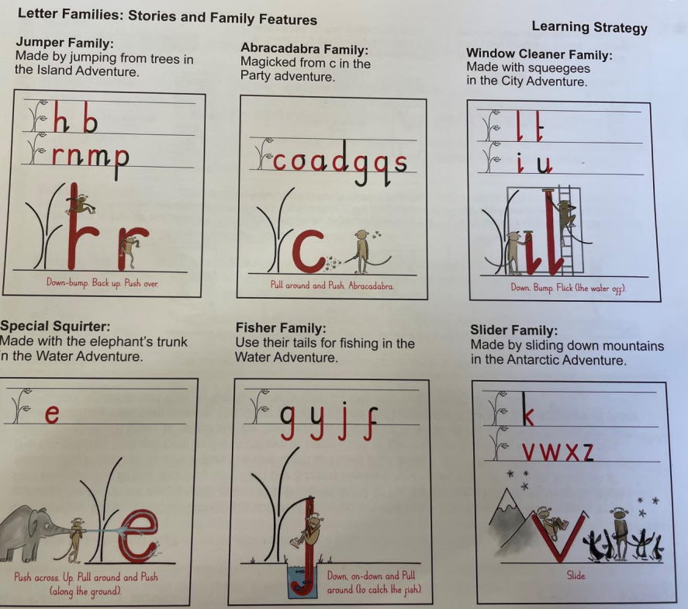

The Four Joins:

- Diagonal joins to letters without ascenders (e.g. ai, ar, un)
- Diagonal joins to letters with ascenders (e.g. ab, ul, it)
- Horizontal joins to letters without ascenders (e.g.ou, vi, wi)
- Horizontal joins to letters with ascenders (e.g. wh, ol, ot)

Early Years
Children should develop gross motor skills by practising a number of physical activities, such as walking on unstable surfaces (e.g. large pillows, a flat see-saw) climbing and swinging, catching and balancing. They should also develop fine motor skills through mark making and creating pre-writing shapes in sand or with paint (Appendix 1).
Before children learn how to hold a pencil, they should be encouraged to perform hand strengthening activities (Appendix 2). Children should practise holding a pencil, using the correct grip (Appendix 3), starting to use it to form recognisable letters, as well as being encouraged to practise the correct writing posture (Appendix 4). They should learn to form these letters using the Read Write Inc letter rhymes (Appendix 5).
Reception - Y1
Children should develop fine motor skills through writing pre-writing shapes in their books (Appendix 1). Before writing, children should perform hand strengthening activities (Appendix 2). Students should be explicitly taught the correct writing posture (Appendix 4). They should practise holding a pencil, using the correct grip (Appendix 3), forming recognisable letters that rest on the line. Children should learn to form letters using the Read Write Inc letter rhymes (Appendix 5). This should be an explicit part of phonics lessons. During handwriting lessons, children should be taught to print letters, with reference to the Read Write Inc rhymes, as well as correct number formation (Appendix 6).
Y2
In Year 2, children will continue practising handwriting as before. From Spring 1, students should begin learning to write in a pre-cursive style. By the end of Y2, most children should be able to print words legibly, using upper and lower cases letters, with a finger space in between each word. Some children will be able to write pre-cursively or cursively. Handwriting should be consistent throughout all books.
3-5
Children should develop fine motor skills through writing pre-writing shapes in their books (Appendix 1). Before writing, children should perform hand strengthening activities (Appendix 2). Students should be explicitly taught the correct writing posture (Appendix 4). They should practise holding a pencil, using the correct grip (Appendix 3). During handwriting lessons, children should be explicitly taught how to use the lead ins that enable cursive handwriting, as well as the four joins.
By the end of Y5, most children should be able to write in a clear, fluent cursive style. Handwriting should be consistent throughout all books.

Provision for left-handed children:
At least 10% of the population are left-handed, the majority of whom are boys. All teachers are aware
of the specific needs of left-handed pupils and make appropriate provision:
- paper should be positioned to the left for right handed pupils and to the right for left handed pupils and slanted to suit the individual in either case;
- pencils should not be held too close to the point as this can interrupt pupils’ line of vision;
- left-handed pupils should sit to the left of a right-handed child so that they are not competing
for space;
- extra practice with left-to-right exercises may well be necessary before pupils write left-to-right automatically.
- Children should be encouraged to have the correct sitting posture for good handwriting (Appendix 4)
Pen/Pencil Licence
It is at the discretion of the Headteacher and Deputy Lead to decide on the 5 statements that will lead to a pen licence.

Special Pencil Licence descriptors (printed letters)
- Most letters start at the top of the letter and sit on the line
- Ascenders reach the top of the line
- Descenders go below the line
- Finger spaces are appropriately sized
- Capital letters and lower case letters are appropriately sized

Pen licence descriptors (cursive)
- Letters start on the line from the lead-in
- Ascenders reach the top of the line
- Descenders go below the line
- Capital letters and lower case letters are appropriately sized
- Letters should be joined in the correct places

Once all 5 of these have been shown once, consistently in all books, children can receive a special pencil from school or they can bring in a dark blue pen from home. Children’s progress should be recorded in a table (Appendix 7). Children will receive a certificate upon completion of their chart(Appendix 8). These can be taken away if the quality of the child’s work is not maintained.

Appendices
Appendix 1: Pre-writing shapes
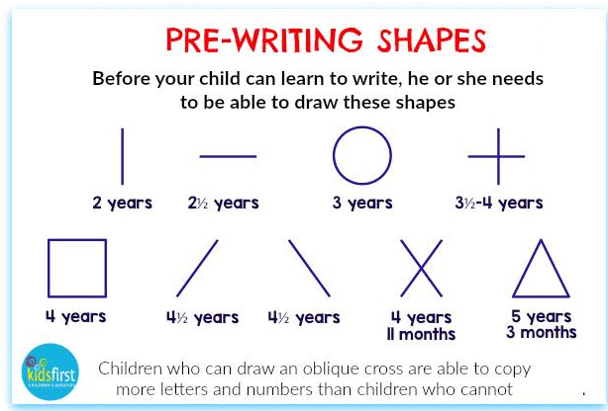

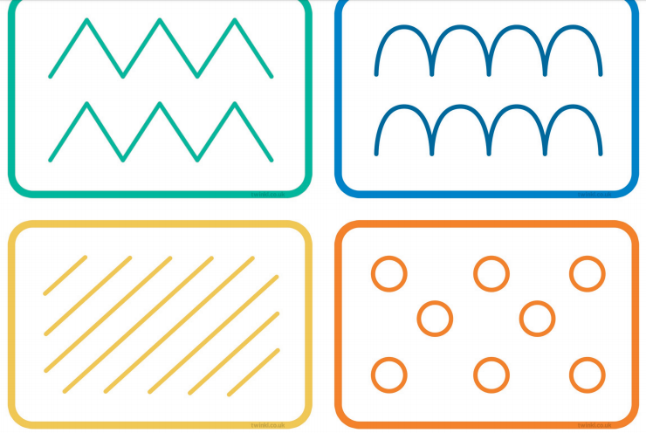
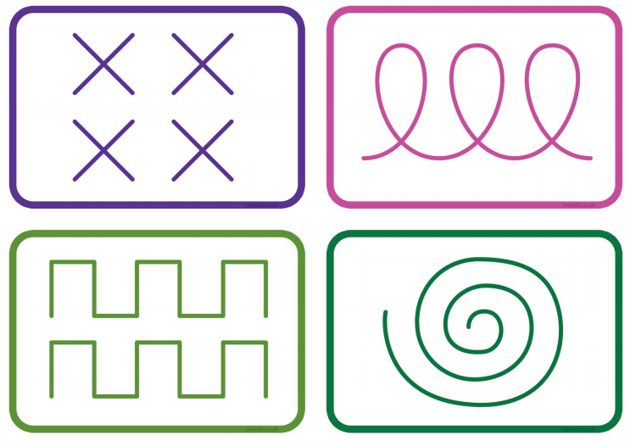
Twinkl Mark Making Pattern Shapes

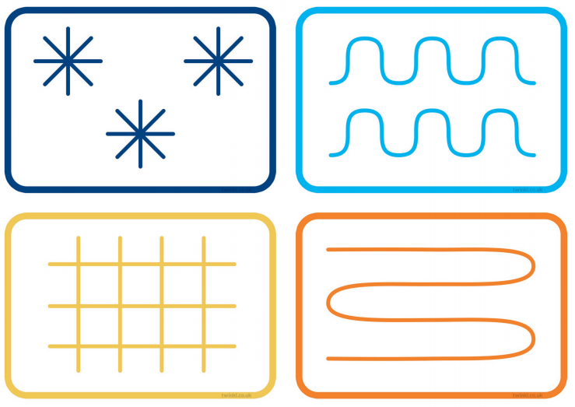
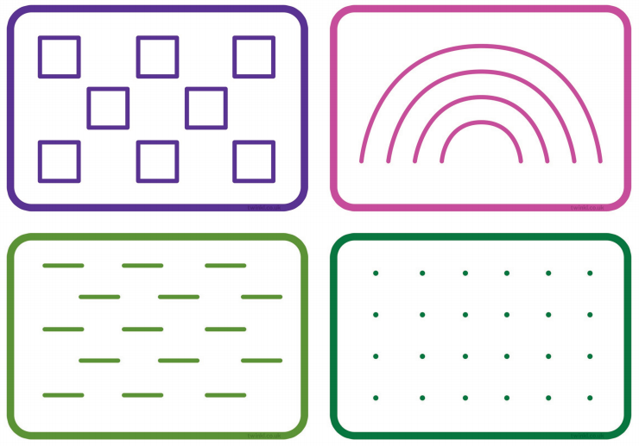

Appendix 2: Hand strengthening activities
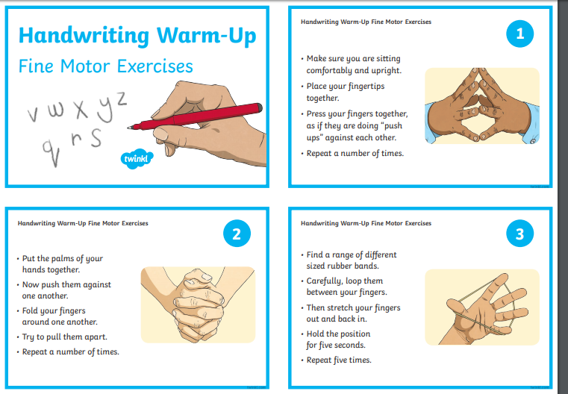

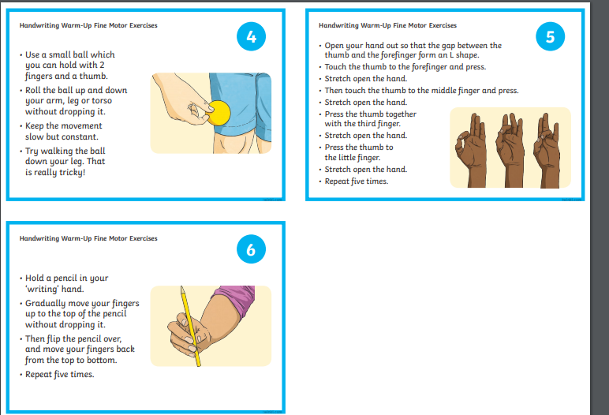

Appendix 3: How to grip a pencil
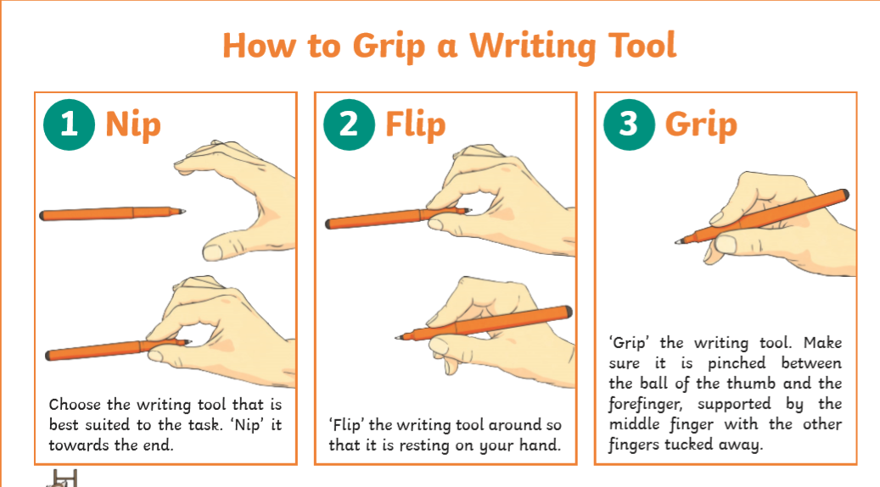

Appendix 4: Correct writing posture
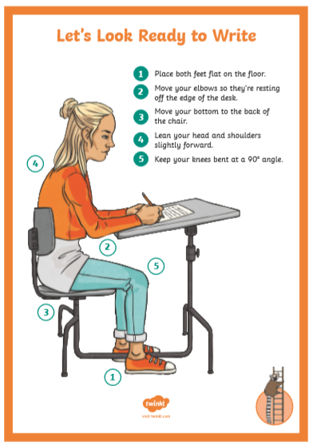

Appendix 5:
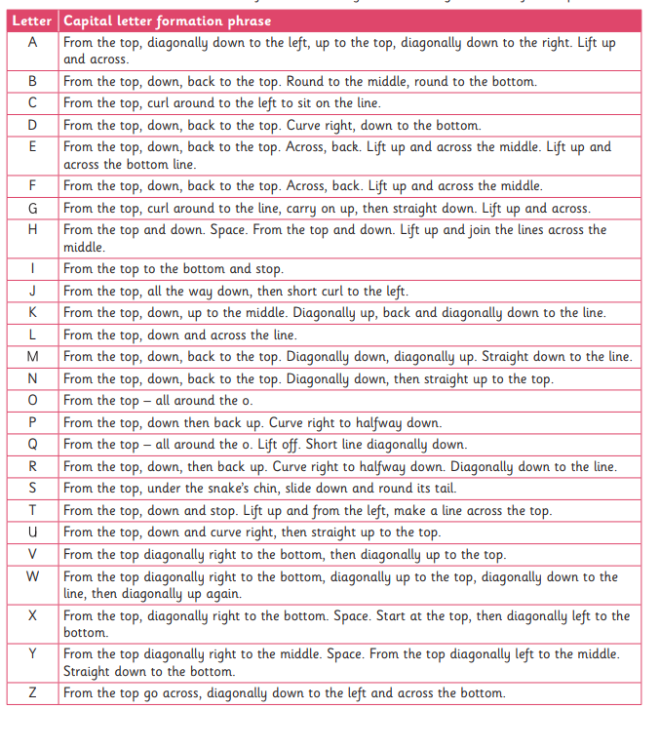

Appendix 6: Correct Number Formation

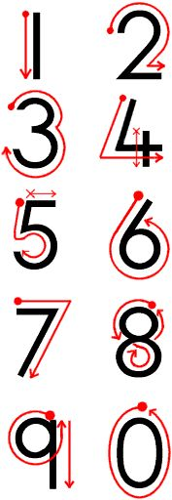

Appendix 7: Left and right handed writing positions

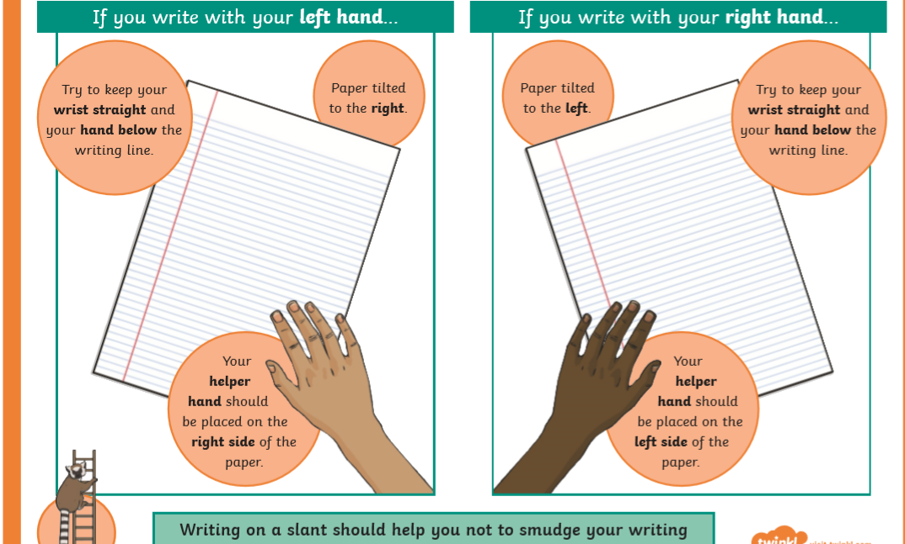

Appendix 7: Handwriting checklist chart
Pencil Licence chart :
Name: | Most letters start at the top and sit on the line | Ascenders reach the top of the line | Descenders go below the line | Finger spaces are appropriately sized | Capital letters are appropriately sized

Pen Licence chart :
Name: | Letters start on the line from the lead-in | Ascenders reach the top of the line | Descenders go below the line | Capital letters are appropriately sized | Letters are joined in the correct places

Appendix 8: Certificates

